# CREATE A SERVICE CALL - STANDARD

**TIMESHEET LEAVE WITHOUT PAY**

## Introduction

Leave without pay will occur when your technician requests time off and they have no annual leave available to take. This needs to be approved by your regional manager (via your branch manager).

When you enter a timesheet into NAXT, it’s expecting at least 8 hours labour for your technician. If there is a shortage on a day’s timesheet because of leave without pay, you’ll need to enter this into NAXT as an absence.

Use this QRG ***after*** you’ve entered your technician’s timesheet into NAXT and ***before*** you add start and end times.

## CALCULATE ABSENCE

**Step 1: Apply Check In and Check Out times**

1A: Select the ‘**Clock-in and out**’ function

1B: Select the ‘**Missing clock in and out**’ button; the ‘Missing’ window will pop up.

1C: Select the ‘**OK**’ button; the ‘Confirm’ window will pop up.

1D: Select the ‘**Yes**’ button.

1E: Check that the clock in and clock out times appear correctly in the time overview.

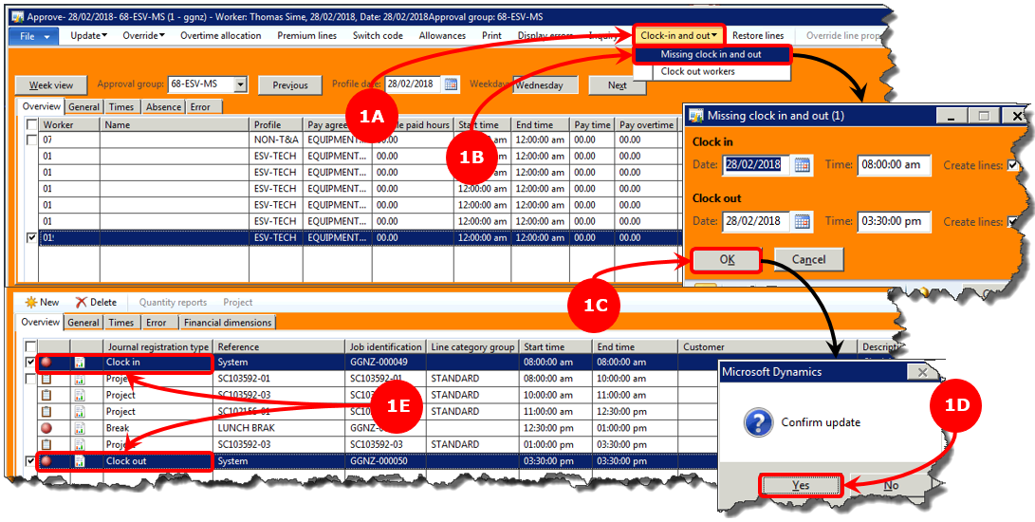

**Step 2: Add absent without leave time**

2A: Select the ‘**Calculated**’ check box for your technician.

*The check box will go grey; a tick will not appear.*

2B: NAXT will generate a new line, called ‘**Absence**’.

*The start and end times are calculated to bring your technician’s hours for the day to 8.*

2C: Select the drop down option in the ‘**Job identification**’ column of the ‘**Absence**’ line.

2D: Select the ‘**NOT ABSENT**’ option.

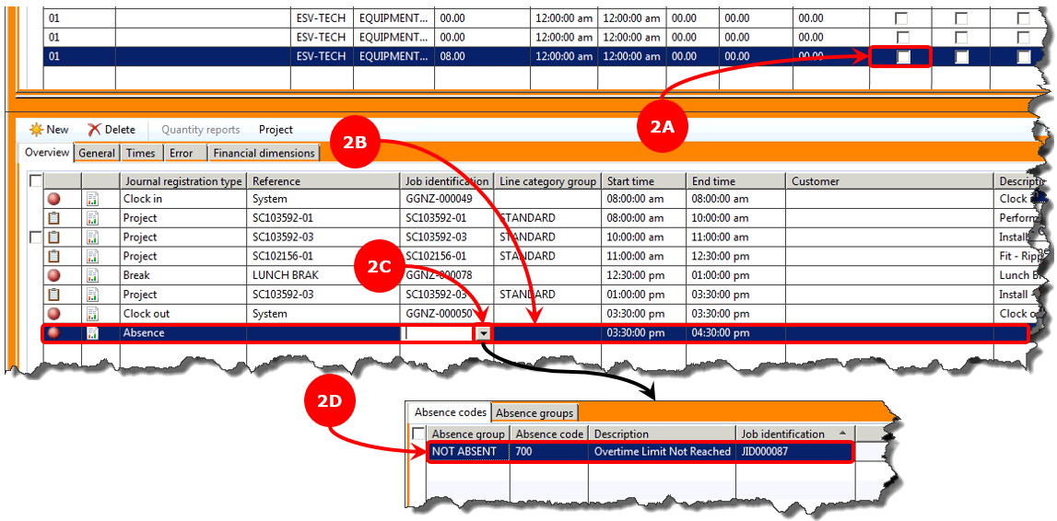

**Step 3: Calculate total time**

3A: Check that the ‘**Job identification**’ column now shows the absence ID and description.

3B: Select the ‘**Calculated**’ check box for your technician.

3C: Check that the ‘**Pay time**’ column for your technician shows a total of ‘8’ hours.

3D: Select the ‘**Transferred**’ check box to complete the timesheet.

